Experiment Number : 12 Date: 26-02-26

Implementation of exception handling in Java
Aim:
To Write a java program to implement exception handling.

PRE LAB EXERCISE
QUESTIONS
- What is exception handling in Java?
Exception handling is a mechanism in Java used to handle runtime errors so that the program doesn't crash.
It allows the program to:
- Detect errors (exceptions)
- Handle them in a controlled way
- Continue execution smoothly

- What is the purpose of using try-catch blocks in exception handling?
Purpose of try–catch:
try block
Contains the code that might cause an exception.
catch block
Contains the code to handle the exception when it occurs.
- try → “Try to run this risky code.”
- catch → “If something goes wrong, handle it here instead of crashing.”

IN LAB EXERCISE
Objective
To understand and implement exception handling through try-catch and finally blocks.
Source Code
package unit2;
import java.util.InputMismatchException;
import java.util.Scanner;
public class Acress {

public static void main(String[] args) {
Scanner scanner = new Scanner(System.in);
try {
System.out.print("Enter an integer: ");
int num = scanner.nextInt();
int result = 10 / num;
System.out.println("Result: " + result);
} catch (InputMismatchException e) {
System.out.println("Invalid input! Please enter an integer.");
} catch (ArithmeticException e) {
System.out.println("Cannot divide by zero!");
} finally {
scanner.close();
System.out.println("Program execution completed.");
}
}

}
Outputs
Output 1 (Valid Input - Non-zero Integer):
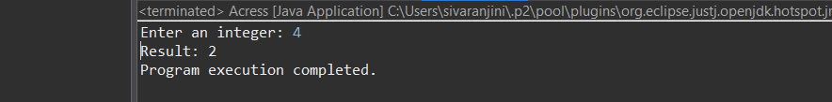
Output 2 (Valid Input - Zero):
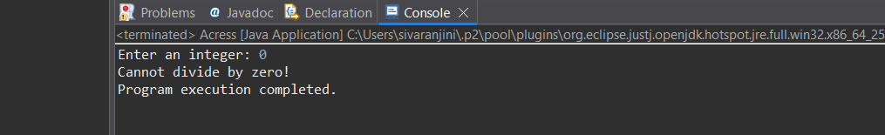
Output 3 (Invalid Input - Non-integer):
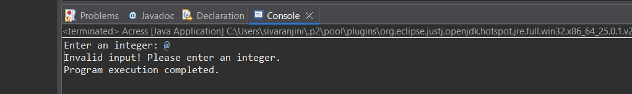

POST LAB EXERCISE
- What is the purpose of the Scanner object in the Java program?
The Scanner object is used to take input from the user at runtime.
It can read:
- integers (nextInt())
- decimals (nextDouble())
- strings (nextLine())
- characters (indirectly)

- What exceptions are expected to be thrown in the code within the try block? Why?
When using Scanner sc = new Scanner(System.in); and reading:
int qty = sc.nextInt();
the common exception is:
InputMismatchException
Why?
This happens when the user enters a value that does not match the expected data type.
Example:
- Program expects an integer
- User enters text like “abc”
→ Java cannot convert this to an int → throws InputMismatchException

ASSESSMENT

Description | Max Marks | Marks Awarded
Pre Lab Exercise | 5
In Lab Exercise | 10
Post Lab Exercise | 5
Viva | 10
Total | 30
Faculty Signature

